**Part I: Study of the impacts of renewable connection to the distribution network.**

• *Scenario N°1: connection of a photovoltaic producer (Gen 4) at the node N°13*

• *Scenario N°2: connection of a photovoltaic producer (Gen 4) at the node N°9.*

• *Scenario N°3: connection of two generators (Gen 3 and Gen 4) respectively at the node N°12*

*andN°13.*

*Question N°1.1: for the first scenario, make a simulation over 1 year. Comment*

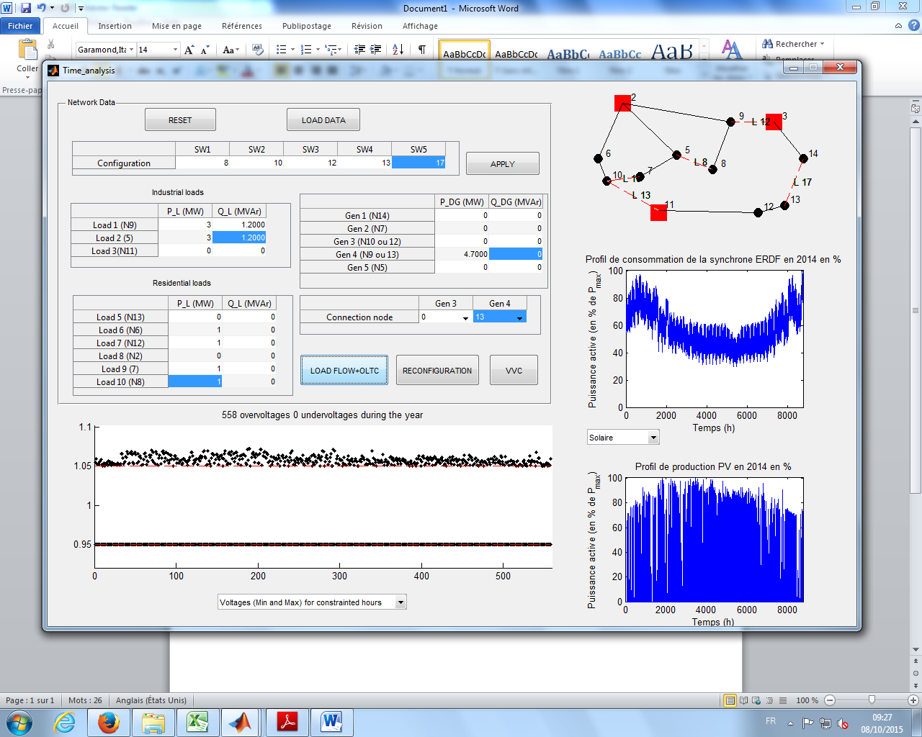

Observation: There are 558 overvoltages when photo-voltaics (Pmax=4.7 MW) are used at Node 13.

Inference: Overvoltages are a result of over-production of real power at a particular bus. Solar installations are modeled as constant power producing units. When solar is conected to Node 13, not much can be said about its impact on the entire system. However, the likely cause can be overvoltages in buses 12 and 13 due to connection of solar power on bus 13. Solar provides a maximum of around 4.7 MW during the day time at 1300 hours. The consumption of these buses at several hours are less than the power produced. Hence the current flows back towards the substation due to over-production. Other buses are consumers of load at all the moments. So, the power is flowing

Maximum load at 2100 hours= 3+3+4*0.69*1=8.8 MW

Maximum power generation at

*Question N°1.2: what happens if the producers are based on wind power?*

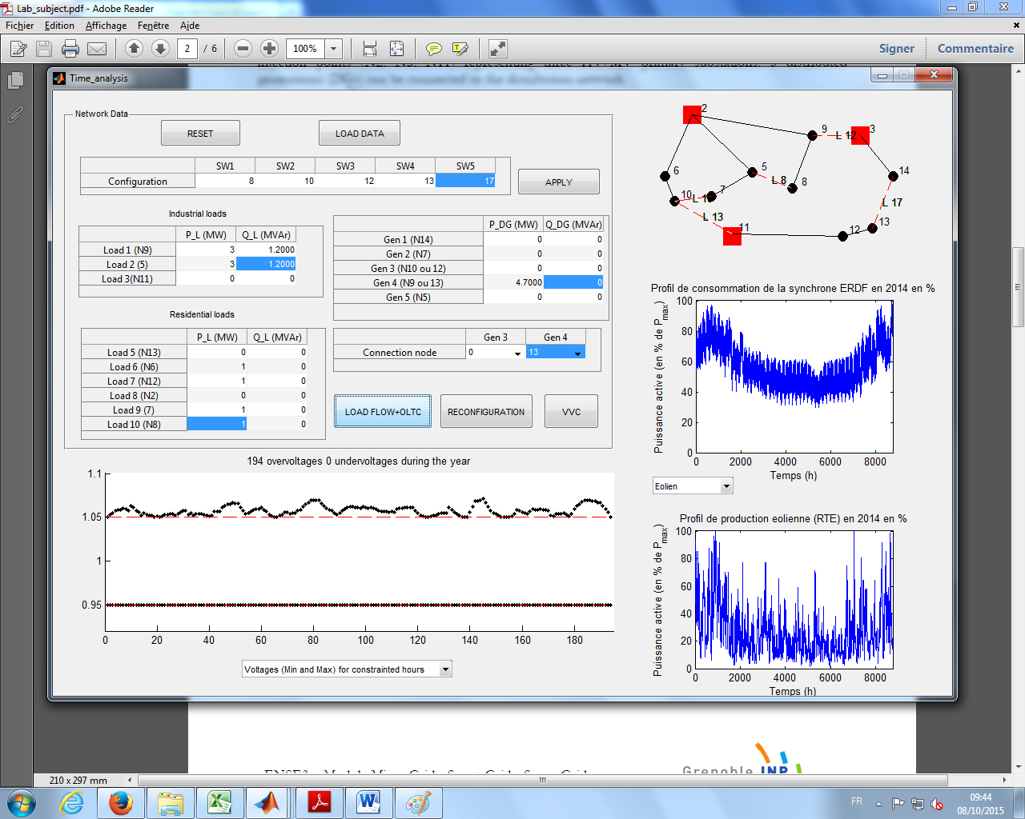

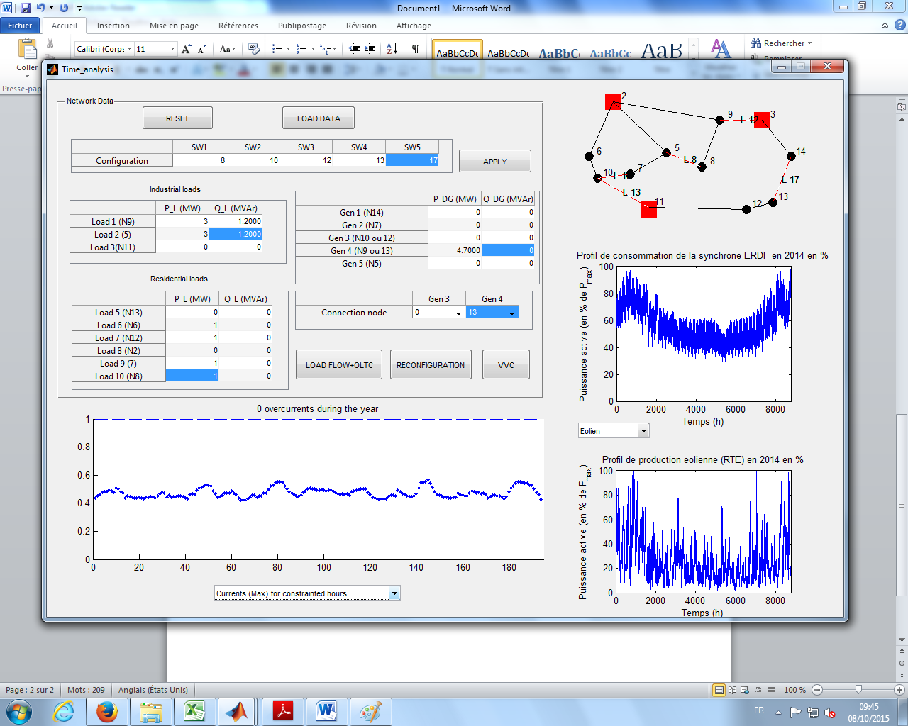

Observation: There are 194 overvoltages when wind power (Pmax=4.7 MW) are used at Node 13.

Inference: Overvoltages are a result of over-production of real power at a particular bus.

*Question N°1.3: for each scenario detailed below, simulate the 5 step times pointed out in figure 3. For each step times, in case of constraints, try to find the best settings of the OLTC of the three HV/MV substations.*

Scenario 1

|  |  |  |  |  |  |  |  |  |  |  |  |
| --- | --- | --- | --- | --- | --- | --- | --- | --- | --- | --- | --- |
|  | Load 6 Pl | Load 7 Pl | Load 9 Pl | Load 10 Pl | Gen 3 Pl | Gen 4 Pl | Gen 3 connection node | Gen 4 connection node | OLTC Node e 2 | OLTC Node e 3 | OLTC Node e 11 |
| 1 | 0.332 | 0.332 | 0.332 | 0.332 | 0 | 0 | 0 | 13 | 1.04 | 1.03 | 0.9750 |
| 2 | 0.638 | 0.638 | 0.638 | 0.638 | 0 | 4.465 | 0 | 13 | 1.03 | 1.03 | 0.95 |
| 3 | 0.60 | 0.60 | 0.60 | 0.60 | 0 | 4.7 | 0 | 13 | 1.03 | 1.03 | 0.95 |
| 4 | 0.498 | 0.498 | 0.498 | 0.498 | 0 | 2.9610 | 0 | 13 | 1.03 | 1.03 | 0.95 |
| 5 | 0.689 | 0.689 | 0.689 | 0.689 | 0 | 0 | 0 | 13 | 1.04 | 1.03 | 0.9750 |

|  |  |
| --- | --- |
|  |  |
| 1 |  |
| 2 |  |
| 3 |  |
| 4 |  |
| 5 |  |

Scenario 2

|  |  |  |  |  |  |  |  |  |  |  |  |
| --- | --- | --- | --- | --- | --- | --- | --- | --- | --- | --- | --- |
|  | Load 6 Pl | Load 7 Pl | Load 9 Pl | Load 10 Pl | Gen 3 Pl | Gen 4 Pl | Gen 3 connection node | Gen 4 connection node | OLTC Node e 2 | OLTC Node e 3 | OLTC Node e 11 |
| 1 | 0.332 | 0.332 | 0.332 | 0.332 | 0 | 0 | 0 | 9 | 1.03 | 1.03 | 1 |
| 2 | 0.638 | 0.638 | 0.638 | 0.638 | 0 | 4.465 | 0 | 9 | 1.03 | 1.03 | 1 |
| 3 | 0.60 | 0.60 | 0.60 | 0.60 | 0 | 4.7 | 0 | 9 | 1.03 | 1.03 | 1 |
| 4 | 0.498 | 0.498 | 0.498 | 0.498 | 0 | 2.9610 | 0 | 9 | 1.03 | 1.03 | 1 |
| 5 | 0.689 | 0.689 | 0.689 | 0.689 | 0 | 0 | 0 | 9 | 1.04 | 1.03 | 1 |

|  |  |
| --- | --- |
|  |  |
| 1 |  |
| 2 |  |
| 3 |  |
| 4 |  |
| 5 |  |

Scenario 3

|  |  |  |  |  |  |  |  |  |  |  |  |
| --- | --- | --- | --- | --- | --- | --- | --- | --- | --- | --- | --- |
|  | Load 6 Pl | Load 7 Pl | Load 9 Pl | Load 10 Pl | Gen 3 Pl | Gen 4 Pl | Gen 3 connection node | Gen 4 connection node | OLTC Node e 2 | OLTC Node e 3 | OLTC Node e 11 |
| 1 | 0.332 | 0.332 | 0.332 | 0.332 | 0 | 0 | 12 | 13 | 1.04 | 1.03 | 0.9750 |
| 2 | 0.638 | 0.638 | 0.638 | 0.638 | 4.465 | 4.465 | 12 | 13 | 1.04 | 1.03 | 0.95 |
| 3 | 0.60 | 0.60 | 0.60 | 0.60 | 4.7 | 4.7 | 12 | 13 | 1.04 | 1.03 | 0.95 |
| 4 | 0.498 | 0.498 | 0.498 | 0.498 | 2.9610 | 2.9610 | 12 | 13 | 1.04 | 1.03 | 0.95 |
| 5 | 0.689 | 0.689 | 0.689 | 0.689 | 0 | 0 | 12 | 13 | 1.04 | 1.03 | 0.9750 |

|  |  |
| --- | --- |
|  |  |
| 1 |  |
| 2 |  |
| 3 |  |
| 4 |  |
| 5 |  |

*Question N°1.4: Conclude on the impacts of renewable generation connected to the distributionnetwork.*

